# The networking Challenge

Some sites are banned in Thapar university which has raised an outcry among ‘some’ students. This is done by adding these sites as part of the ‘Banned’ list in the configuration of ‘Cyberroam’, Thapar’s internet security watchdog.

One hacker student among them started exploring ways which can allow his hostel mates to access these banned sites. He connected his system to internet using some other personal access point. Having done that, he configured his friends PC’s to route the internet (HTTP) traffic to his PC, which forwarded it to the internet. This way his hostel mates can access all sites using the other internet access point.

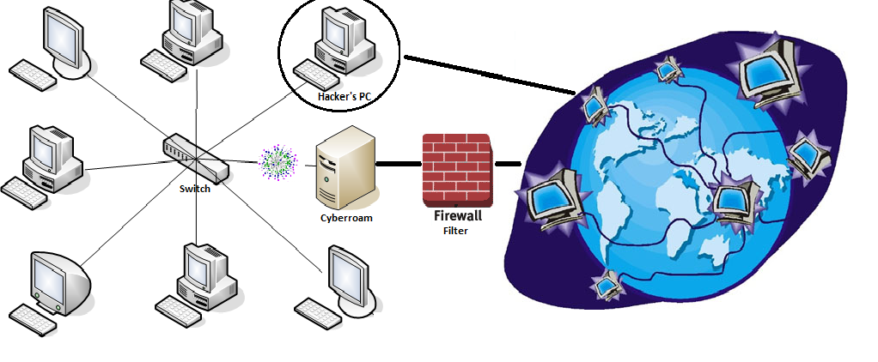

The network in this LAB (topologically similar to the one in the figure above) is a similar environment to a hostel’s network and one of the PC’s is connected to the internet from a different gateway as depicted the figure above.

You are in a similar scenario as depicted in the figure above. Normally traffic from your PC is routed to cyberroam, which won’t allow you to access these sites. The hacker’s PC is a bit different from the cyberroam. It has a **server application** that listens on a particular port and forwards all the incoming traffic to the internet. It automatically creates a mapping and gives exclusive internet access to each PC, connected to it on the particular port.

Your job is to search for this **open port number** (that can give you internet access) and the corresponding IP address of the Hacker’s PC. Then practically route all your HTTP traffic ‘**to the particular port of the other gateway’** (Hacker’s gateway). Having done that successfully you should be able to access, the otherwise banned website <http://www.facebook.com/>.

Q. What is the IP address of the hacker’s PC? ____________________________________

Q. What is the port number to which you need to connect? _________________________

* The network you are connected to is a 172.31.4.* network and all the PC’s in this LAB including the HACKER’s PC lies in the range 172.31.4.133 to 172.31.4.199